**DISCUSSION**

In this thesis I explored how natural and altered environmental conditions shape the ecology of riparian plant communities. In this final chapter I aim to summarise the contribution of my thesis to the greater body of riparian plant ecology and river restoration research, outline outstanding questions raised by my work, and present some possible avenues for future work.

BIOGEOGRAPHIC CONTEXT

(Mason et al. 2013)The riparian plant communities described here were located primarily along coastally drained, mid-catchment rivers in partially constrained valley settings, spanning temperate and subtropical south-eastern Australia. A map showing field sites surveyed in Chapters 2-4 is shown below (Fig. 1). Although no systematic review has summarised ecological knowledge of Australian riparian plant communities, more research attention appears to have been focused on semi-arid, inland-draining systems such as the Murray Darling Basin, or larger tropical rivers, than these smaller coastal systems.

Additionally, much of the canonical riparian plant ecology literature was written about alluvial river systems in Europe and North America (Nilsson et al. 1989; Naiman and Decamps 1997; Tabacchi et al. 1998; Naiman et al. 2005; Corenblit et al. 2007). Flow regimes in south-eastern Australia diverge considerably from this canon: the seasonal regularity which characterises nival European and North American rivers is often replaced by substantial year-on-year variability (Finlayson and McMahon 1988; Peel et al. 2004). South-eastern Australian plants do exhibit characteristic species-level responses to seasonality, although there is no general coordination of growth and reproduction phenologies as in the Northern Hemisphere (Ford, Paton & Forde, 1979). As such, Australian riparian plant communities are likely to be adapted to different environmental controls. In common with North American systems, however, the signature of rapid landscape modification has been etched deeply into fluvial landscapes. Many rivers have undergone irreversible state transitions following European settlement (Knopf et al. 1988; Fleischner 1994; Wasson 1994; Brierley et al. 1999), and the mid-20th century saw the rise of extensive flow impoundment schemes in both continents (Lloyd et al. 2004; Graf 2006).

This body of work therefore contributes fresh perspective to the global literature, from species pools subject to a different evolutionary history and operating under different environmental conditions to the most commonly described riparian ecosystems.

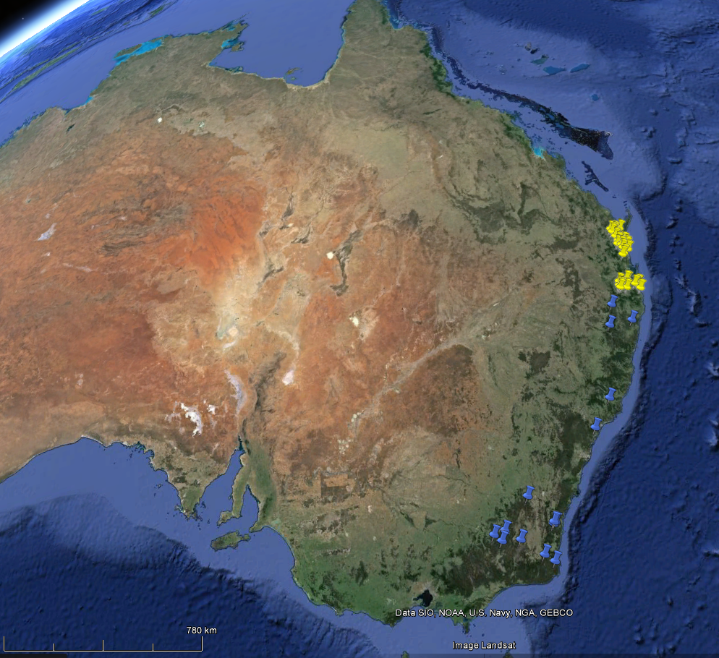

Figure . Map showing geographical distribution of field sites from Chapters 2 & 3 (blue) and 4 (yellow) (Google Maps 2015).

ECOLOGICAL RESPONSES OF RIPARIAN PLANT COMMUNITIES TO FLUVIAL HYDROLOGY

The relationship between environmental heterogeneity and biodiversity has been a key concern of ecologists since the early 1960’s (MacArthur and MacArthur 1961; Stein et al. 2014). Riparian landscapes provide particularly useful model systems for exploring hypotheses about environmental heterogeneity due to strong control of biotic assemblages by fluvial hydrology, and in tandem with disturbance, hydrologically driven environmental heterogeneity has taken a central role in our conceptualisation of how riparian ecosystems function (Poff et al. 1997; Naiman et al. 2005).

Chapters 2, 3 and 4 tested hypotheses derived from this paradigm. Broadly, my work confirms the importance of hydrological heterogeneity and fluvial disturbance in shaping riparian plant assemblages. The specific contribution of these chapters to the riparian literature lies in our mechanistic, functional trait based approach. Through the lens of functional traits, we have begun to address questions about how flow regime influences ecological strategies of riparian plants at the community level, and how the functional organisation of communities varies along hydrological gradients.

In Chapter 2, we found that wood density, a functional trait associated with resistance to mechanical disturbance and drought tolerance (Chave et al. 2009; Niklas and Spatz 2010), varied strongly in response to patterns of hydrology. Community mean values of wood density increased with the intensity of fluvial disturbance and flow heterogeneity; communities which experienced more variable flow conditions were shifted towards the ‘slow’, conservative end of the spectrum of resource-economic ecological strategies (Reich 2014). Wood density in turn influences wood decomposition rates (Mori et al. 2013) which has implications for ecosystem nutrient cycling and energetic fluxes in riparian ecosystems (Harmon et al. 1986), as well as for the residency time of geomorphically active large woody debris in river systems (Gurnell et al. 2002; Cadol and Wohl 2010). We also found a humped relationship between community-weighted variance in wood density and the same combined gradient of disturbance and hydrological heterogeneity, lending evidence to general hypotheses (from outside of the riparian literature) that intermediate levels of disturbance should promote divergence in disturbance-response strategies (Grime 2006; Sonnier et al. 2010). Given the substantial cost incurred in setting down dense woody tissue (Falster 2006), these findings demonstrate that some of the key trade-offs negotiated by plants in riparian communities are made in response to fluvial disturbance and hydrological heterogeneity.

Plant life forms and qualitatively derived functional groups have been used for some time to describe functional organisation in riparian plant communities (Brinson 1993; Stromberg et al. 2010; Stromberg 2013). In Chapters 3 & 4 we derived quantitative, continuous indices of functional diversity from vegetation survey and data about a range of functional traits capturing key axes of variation riparian in plant ecological strategy. Using functional traits as descriptors of ecological strategy negates any requirement for expert knowledge required to assign species to qualitative functional groups. These indices of functional diversity also facilitate the use of quantitative modelling methods (Mason et al. 2013), and allow more solid inferences to be made about how individual components of flow regime influence community assembly and ecosystem processes than are possible using taxonomic metrics of diversity (Tilman et al. 1997; Díaz et al. 1998).

Patterns of variation in functional dispersion measured in natural landscapes of coastal south-eastern Australia (described in Chapter 3) showed strong positive relationships with metrics describing hydrological heterogeneity. While we did not systematically describe variation in species richness along hydrological gradients, species richness (but not the number of species used in the functional dispersion analysis) was significantly positively correlated with functional dispersion. We were able to generate a multiple regression model which explained 80 % of the total variation in functional dispersion using three hydrological metrics. Partitioning of variance between this model and optimal models generated using climatic and soil variables showed that a substantial proportion of variance explained by hydrology was not co-explained by climate or soil, further demonstrating the dominance of fluvial disturbance and flow variability in shaping the functional structure of these plant communities.

Riparian plant communities in south-eastern Queensland (described in Chapter 4) showed somewhat different responses to hydrology. Several additional environmental variables were taken into account to quantify the degree of anthropogenic modification both to the surrounding catchment and to the flow regime itself. In this study, we found functional richness and functional divergence (as measured by abundance-standardised functional dispersion) were associated with only a limited subset of metrics describing hydrological heterogeneity, and variance partitioning of models showed that relatively little variation in either functional richness or divergence was explained by hydrology when climate and soil properties were taken into account. Flow modification did explain some variation in metrics of functional diversity, but again, not independently. Contrary to our hypotheses, and to patterns commonly described in Northern hydroecological systems (e.g. Naiman and Decamps 1997), species richness fell as flow regimes became more heterogeneous. The observation that species richness and metrics of functional diversity showed opposite relationships with the same hydrological variables allowed us to determine that communities living under hydrologically heterogeneous conditions were maintaining functional diversity with reduced a reduced species pool.

*Outstanding questions about the role of hydrological heterogeneity in structuring communities*

Thus although hydrology was the dominant control on functional traits and functional trait diversity in both regions analysed here, the relative importance of hydrological heterogeneity *per se* differed. Some of the major outstanding questions in this thesis are why this might have been so, and which aspects of my findings are generalisable to systems in other regions within Australia and across the globe?

It is possible that Australian plant communities in fact have unique relationships with flow heterogeneity, given Australia’s title of “planet’s most hydrologically variable continent” (Finlayson and McMahon 1988; Peel et al. 2004). A larger comparative study of factors shaping the functional ecology of riparian plant communities would be an essential step towards finding generalities in flow heterogeneity-diversity relationships, and would also provide further opportunity to investigate discontinuities in trends. Riparian researchers are becoming more interested in functional ecology, and it is possible that we will see global syntheses being made over the next decade. Research in regions underrepresented in the riparian ecology literature, such as the tropics and the developing world, would be of particular value in this endeavour.

Absent an exhaustive global comparative synthesis, comparing the specific findings of Chapter 3 and Chapter 4 reveals a possible explanation for their differences. While functional diversity of communities described in Chapter 2 scaled monotonically with most metrics of flow variability, and was positively associated with species richness, functional diversity of communities in south-eastern Queensland (Chapter 4) was significantly associated with only a small set of metrics of describing flow variability (e.g. interannual variability in baseflow index, constancy of monthly maximum flows) and in those cases, relationships were better described by quadratic models. As noted previously, species richness showed inverted relationships with these metrics. To properly compare the results of these two chapters, a methodological issue must first be addressed: functional dispersion (FDis), *sensu* Laliberté and Legendre (2010), was used in Chapter 3, while standardised effect size FDis (FDis.SES), *sensu* Mason et al. (2013), was used in Chapter 4 as a measure of functional divergence. With the exception of a few outliers, FDis was tightly positively correlated with FDis.SES for the south-east Queensland dataset (Pearson’s r = 0.75). With respect to species richness, this confirms that standardising FDis for abundance was not responsible for inverting the species richness – functional diversity relationship.

In our discussion of Chapter 4, we noted that rhythmicity in temporal patterns of energy and resource availability and environmental heterogeneity may both act as controls on riparian plant diversity, citing recent work showing that rhythmic seasonal flow activity fosters greater diversity in birds and fishes and greater net primary production in plant communities (Jardine et al. 2015), and that energy (and resource) availability may be more important than environmental heterogeneity in determining patterns of diversity (Lundholm 2009). Thus differences between findings of Chapters 3 and 4 could be explained by differences in the influence of these two factors. For this conceptual model to be useful, we need to describe some key components of its structure. Firstly, is it flow rhythmicity *per se* which is important, or simply total energy availability, which happens to be maximised in rhythmic systems? If the former, can flows be both heterogeneous and rhythmic, or are the two factors inherently opposite? For example, can a river with high interannual variability in its baseflow index also experience highly regular summer flood flows? Perhaps cases at extreme ends of each spectrum are less interesting than those at intermediate levels of heterogeneity and energy availability / rhythmicity.

Perhaps a better way of conceptualising environmental control over diversity might be as a three dimensional relationship, where heterogeneity and energy availability (or flow rhythmicity) are incompletely orthogonal to each other. The curves presented in this thesis would then be two dimension slices of a three dimensional volume. A challenge for future research in this field is therefore to explicitly include energy availability or flow rhythmicity in hypotheses about flow responses of plant communities, and to attempt to characterise how communities respond to both factors simultaneously.

RESPONSES OF RIPARIAN PLANT COMMUNITIES TO ANTHROPOGENIC ENVIRONMENTAL CHANGE

My interest in the functional ecology of riparian plant communities was initially motivated by the need for new approaches and perspectives towards conserving, rehabilitating and managing riparian landscapes in south-eastern Australia. The 20th century has seen unprecedented change in riverine ecosystems, and these changes are likely to intensify over the current century. Compared with Europe and North America, applied river rehabilitation in Australia is somewhat hampered by a lack of basic ecological knowledge. Thus one of the main aims of my thesis was to inform management with new information about riparian ecology in both natural and modified landscapes.

*How might riparian plant communities respond under climate change?*

Climate change is predicted to have global impacts on ecosystems in the 21st century (IPCC 2014). Riparian ecosystems are likely to be particularly vulnerable due to their high exposure and sensitivity to changes in climate, in combination with pressures associated with extraction of provisioning ecosystem services by humans (Capon et al. 2013). Elevated concentrations of carbon dioxide (eCO2) represent the most direct and obvious change to the atmosphere. The potential influence of eCO2 on plants and plant communities has been the topic of intensive research over the last two decades. To date, however, the implications for conservation management under high CO2 regime are highly species and system specific, and are likely to be contingent on a slew of other environmental factors (Poorter and Navas 2003; Norby and Zak 2011; Poorter et al. 2011; Reich et al. 2014). Basic research on the ecological effects of eCO2 is needed for individual systems, and each piece of experimental work contributes to the greater outlook.

Of the three anthropogenic alterations investigated in this thesis, elevated atmospheric CO2 (eCO2) had the smallest effect. We showed that eCO2 significantly stimulated growth in only one of three riparian tree seedlings, and this effect was completely negated by inundation. Inundation itself had strong effects on gas exchange, growth and functional traits in all three species. Differential responses between species to combined waterlogging and eCO2 may have flow-on effects on demographics, competition, and ultimately, community composition.

Our study contributes to what is currently a very small set of publications investigating the potential for interactive effects between future atmospheric concentrations of CO2 and inundation or waterlogging events on terrestrial plants (Megonigal et al. 2005; Shimono et al. 2012; Arenque et al. 2014). We included an analysis of functional trait responses, as well as including a recovery phase in our experiment, neither of which have been previously attempted to our knowledge. Fruitful avenues for future work include study of more species, serial waterlogging treatments to better understand how eCO2 influences on waterlogging recovery, analysis of leaf nutrient concentrations to determine the role of nutrient limitation in blunting growth stimulation by eCO2 (Reich et al. 2014), and mesocosm experiments to investigate the implications of eCO2 – waterlogging interactions for competition.

Greater hydrological variability and intensity of extreme weather events characterise models of high CO2 climates (Hennessy et al. 2008; Stocker et al. 2013). Our research demonstrates that riparian plant communities vary substantially in their taxonomic and functional composition over gradients of hydrological heterogeneity. As discussed in previous chapters, the changing climate is likely to enhance dominance of variability-tolerant ecological strategies associated with traits such as high wood density, and push communities towards more dispersed functional structures. In species-rich communities of south-east Queensland, increased flow heterogeneity may have important consequences for taxonomic diversity, functional redundancy and ecosystem resilience. Greater exotic abundance was associated with more heterogeneous systems in south-eastern Queensland. Despite the lack of association between of flow modification and exotic abundance in our study, it remains possible that climate-related increases in hydrological heterogeneity may also result in invasion by exotic species.

Further work is required to integrate observations about riparian plant community responses to hydrological heterogeneity with climate change predictions. Functional trait approaches are likely to be particularly useful in the absence of detailed species-level ecological knowledge.

*Could environmental flows be a useful tool for river rehabilitation in south-eastern Australia?*

Hydrology was confirmed as the ‘master variable’ controlling riparian plant communities (Poff et al. 1997) in both field studies, but flow modification also had a profound influence over species richness in south-eastern Queensland. That homogenised flows were actually associated with increased species richness (and functional diversity, to some extent) runs counter to much of the riparian literature on flow modification (Lytle and Poff 2004). As discussed above, increased flow rhythmicity may underlie this unexpected effect. The lack of any association between flow modification and abundance of exotic species also opposes the general body of literature (Catford et al. 2011; Greet et al. 2012). Catchment land use and soil properties explained a substantial proportion of variation in exotic abundance, and may be more important drivers of invasion in this region.

Environmental flows - flows released from dams which are engineered to mimic natural flow events - are the focus of increasing research effort, and may be an important tool in rehabilitation of modified systems (Arthington 2012),. Frameworks for developing and using environmental flows, such as Ecological Limits of Hydrological Alteration (ELoHA) (Poff et al. 2010), are predicated on the notion that altered flow regimes are the main cause of degradation in riparian ecosystems. The relationship between flow alteration and degradation is clearly defined in some systems, such as those invaded by *Tamarix* *spp*. in south-western North America: flood reduction and homogenised flow regimes result in more invasive *Tamarix* *spp*. and less native *Populus spp.* (Stromberg et al. 2007; Shafroth et al. 2010)*.* Our analysis of patterns of functional diversity in natural landscapes (Chapter 3) led us to conclude that managers should include a component of variability in designed flow regimes to simulate natural flow heterogeneity. In south-east Queensland, the situation is more complicated, and the feasibility of using environmental flows for conservation or restoration depends on the desired outcome. Supporting indigenous biodiversity over exotic species, improving geomorphic condition, generating habitat complexity and maintaining or restoring lost ecosystem processes and services are common desired outcomes for environmental flows (Richter and Thomas 2007; Poff et al. 2010; Meitzen et al. 2013). South-east Queensland communities were particularly sensitive to modification of contingency of monthly minimum flows (year on year variability in monthly minimum flow patterns), suggesting management efforts aimed solely at maximising taxonomic diversity would do well to increase flow contingency. This approach is risks shifting community composition, but may be a reasonable response to offset greater climatic variability under future climates. Our research in south-east Queensland had rather less to say about the potential utility of environmental flows in directing functional diversity and associated ecosystem functionality. Flow modification largely did not have a consistent effect on functional diversity, suggesting that funds and effort may be better spent on local initiatives within catchments, such as improving landholder engagement in rehabilitation projects.

CONCLUSION

Awareness of the economic, societal and intrinsic value of Australian waterways is increasing, and the field of riparian ecology is now progressing rapidly in Australia. We are finding commonalities with more extensively studied river systems in other parts of the world, and also new patterns and processes which give Australian river systems a unique character. I attempted to answer some basic questions about riparian plant communities in south-eastern Australia using methods from modern plant ecology. In my first two studies I was able to clearly validate my hypotheses, while in the third and fourth studies a more complex and unexpected picture arose. Hopefully, I have set a useful stage for further work on the functional ecology of riparian plant communities, and my basic research informs more applied aspects of river management and rehabilitation.